**PHP File() Function: File_exists, Fopen, Fwrite, Fclose, Fgets, copy, unlink**

**What is a File?**

A file is simply a resource for storing information on a computer.

Files are usually used to store information such as;

* Configuration settings of a program
* Simple data such as contact names against the phone numbers.
* Images, Pictures, Photos, etc.

**In this tutorial, you will learn-**

* [PHP File Formats Support](https://www.guru99.com/php-file-processing.html#1)
* [PHP files Functions](https://www.guru99.com/php-file-processing.html#2)
* [PHP File_exists Function](https://www.guru99.com/php-file-processing.html#3)
* [PHP Fopen Function](https://www.guru99.com/php-file-processing.html#4)
* [PHP Fwrite Function](https://www.guru99.com/php-file-processing.html#5)
* [PHP Fclose Function](https://www.guru99.com/php-file-processing.html#6)
* [PHP Fgets Function](https://www.guru99.com/php-file-processing.html#7)
* [PHP Copy Function](https://www.guru99.com/php-file-processing.html#8)
* [Deleting a file](https://www.guru99.com/php-file-processing.html#9)
* [PHP File_get_contents Function](https://www.guru99.com/php-file-processing.html#10)

**PHP File Formats Support**

PHP file functions support a wide range of file formats that include;

* File.txt
* File.log
* File.custom_extension i.e. file.xyz
* File.csv
* File.gif, file.jpg etc
* Files provide a permanent cost effective data storage solution for simple data compared to databases that require other software and skills to manage DBMS systems.
* You want to store simple data such as server logs for later retrieval and analysis
* You want to store program settings i.e. program.ini

**PHP files Functions**

PHP provides a convenient way of working with files via its rich collection of built in functions.

Operating systems such as Windows and MAC OS are not case sensitive while[Linux](https://www.guru99.com/unix-linux-tutorial.html)or[Unix](https://www.guru99.com/unix-linux-tutorial.html)operating systems are case sensitive.

Adopting a naming conversion such as lower case letters only for file naming is a good practice that ensures maximum cross platform compatibility.

Let’s now look at some of the most commonly used PHP file functions.

**PHP File_exists Function**

This function is used to determine whether a file exists or not.

* It comes in handy when we want to know if a file exists or not before processing it.
* You can also use this function when creating a new file and you want to ensure that the file does not already exist on the server.

The file_exist function has the following syntax.

<?php

file_exists($filename);

?>

HERE,

* “file_exists()” is the PHP function that returns true if the file exists and false if it does not exist.
* “$file_name” is the path and name of the file to be checked

The code below uses file_exists function to determine if the file my_settings.txt exists.

<?php

if (file_exists('my_settings.txt'))

{

echo 'file found!';

}

else

{

echo 'my_settings.txt does not exist';

}

?>

  Save the above code in a file named file_function.php Assuming you saved the file in phptuts folder in htdocs, open the URL **http://localhost/phptuts/file_function.php** in your browser You will get the following results.

[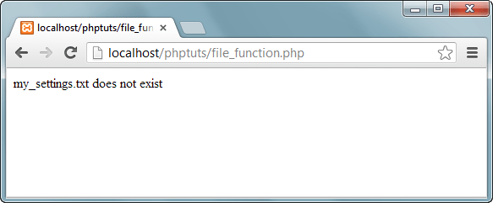](https://www.guru99.com/images/2013/04/file_exists.png)

**PHP Fopen Function**

The fopen function is used to open files. It has the following syntax

<?php

fopen($file_name,$mode,$use_include_path,$context);

?>

  HERE,

* “fopen” is the PHP open file function
* “$file_name” is the name of the file to be opened
* “$mode” is the mode in which the file should be opened, the table below shows the modes

|  |  |
| --- | --- |
| **Mode** | **Description** |
| r | * Read file from beginning. * Returns false if the file doesn’t exist. * Read only |
| r+ | * Read file from beginning * Returns false if the file doesn’t exist. * Read and write |
| w | * Write to file at beginning * truncate file to zero length * If the file doesn’t exist attempt to create it. * Write only |
| w+ | * Write to file at beginning, truncate file to zero length * If the file doesn’t exist attempt to create it. * Read and Write |
| a | * Append to file at end * If the file doesn’t exist attempt to create it. * Write only |
| a+ | * Php append to file at end * If the file doesn’t exist attempt to create it * Read and write |

* “$use_include_path” is optional, default is false, if set to true, the function searches in the include path too.
* “$context” is optional, can be used to specify the context support.

**PHP Fwrite Function**

The fwrite function is used to write files.

It has the following syntax

<?php

fwrite($handle, $string, $length);

?>

  HERE,

* “fwrite” is the PHP function for writing to files
* “$handle” is the file pointer resource
* “$string” is the data to be written in the file.
* “$length” is optional, can be used to specify the maximum file length.

**PHP Fclose Function**

Is is used to close a file in php which is already open

It has the following syntax.

<?php

fclose($handle);

?>

  HERE,

* “fclose” is the PHP function for closing an open file
* “$handle” is the file pointer resource.

Let’s now look at an example that creates my_settings.txt.

We will use the following functions.

* Fopen
* Fwrite
* fclose

The code below “create_my_settings_file.php” implements the above example.

|  |  |
| --- | --- |
| Open a file | <?php  $fh = fopen("my_settings.txt", 'w')  or  die("Failed to create file"); ?> |
| Closing a file | <?php  fclose($fh);  ?> |
| Create File | <?php  $fh = fopen("my_settings.txt", 'w') or die("Failed to create file");  $text = <<<_END  localhost;root;pwd1234;my_database  _END;  fwrite($fh, $text) or die("Could not write to file");  fclose($fh);  echo "File 'my_settings.txt' written successfully"; ?> |

**Testing the code**

Open the URL **http://localhost/phptuts/create_my_settings.php** in your browser.

You will get the following page

. [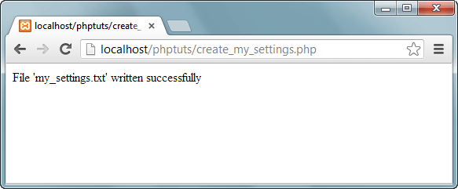](https://www.guru99.com/images/2013/04/write_file.png)

Note: if your disk is full or you do not have permission to write files, you will get an error message.

Switch back to the URL **http://localhost/phptuts/file_function.php** .

What results do you get?

**PHP Fgets Function**

The fgets function is used to read php files line by line. It has the following basic syntax. fgets($handle); HERE,

* “$fgets” is the PHP function for reading file lines
* “$handle” is the file pointer resource.

Let’s now look at an example that reads my_settings.txt file using the fopen and fgets functions.

The code below read_my_settings.php implements the above example.

<?php

$fh = fopen("my_settings.txt", 'r') or die("File does not exist or you lack permission to open it");

$line = fgets($fh);

echo $line; fclose($fh);

?>

  HERE,

* “fopen” function returns the pointer to the file specified in the file path
* “die()” function is called if an error occurs. It displays a message and exists execution of the script

**PHP Copy Function**

The PHP copy function is used to copy files. It has the following basic syntax. copy($file,$copied_file); HERE,

* “$file” specifies the file path and name of the file to be copied.
* “copied_file” specified the path and name of the copied file

The code below illustrates the implementation

<?php

copy('my_settings.txt', 'my_settings_backup.txt') or die("Could not copy file");

echo "File successfully copied to 'my_settings_backup.txt'";

?>

**Deleting a file**

The unlink function is used to delete the file. The code below illustrates the implementation.

<?php

if (!unlink('my_settings_backup.txt'))

{

echo "Could not delete file";

}

else

{

echo "File 'my_settings_backup.txt' successfully deleted";

}

?>

**PHP File_get_contents Function**

The file_get_contents function is used to read the entire file contents.

The code below illustrates the implementation.

The difference between file_get_contents and fgets is that file_get_contents returns the file data as a string while fgets reads the file line by line.

<?php

echo "<pre>"; // Enables display of line feeds

echo file_get_contents("my_settings.txt");

echo "</pre>"; // Terminates pre tag

?>

**Summary**

* A file is a resource for storing data
* PHP has a rich collection of built in functions that simplify working with files.
* Common file functions include fopen, fclose, file_get_contents
* The table below shows a summary of the functions covered

|  |  |
| --- | --- |
| **Function** | **Description** |
| File_exists | Used to determine if a file exists or not |
| fopen | Used to open a file. Returns a pointer to the opened file |
| fwrite | Used to write to files |
| fclose | Used to open closed files |
| fgets | Used to read a file line by line |
| copy | Used to copy an existing file |
| unlink | Used to delete an existing file |
| file_get_contents | Used to return the contents of a file as a string |